System Specification Document
Project: Smart Park – Environmental Monitoring & Recommendation System
Target Location: "Giganti della Sila" Park Team Size: 7 Members
1. Introduction & Objectives
The goal of the Smart Park project is to enhance the visitor experience at the "Giganti della Sila" park through an IoT-driven environmental monitoring system. The system utilizes a Robustel EG5120 Gateway and multi-purpose Robustel-S6000U Smart Sensors to gather real-time environmental data, which is processed using Machine Learning to recommend optimal hiking trails and ensure visitor comfort. Additionally, an AI-powered Chatbot acts as a virtual guide.
To ensure a robust implementation suitable for the team size, the system has been expanded to include predictive weather integration and GPS user localization.
2. System Architecture
The architecture is built around a central "Main Frame" managed by the Robustel EG5120 Gateway, acting as the bridge between physical sensors and digital services.
- Hardware Layer:
  - Robustel EG5120 Gateway: A ruggedized computer serving as the system body.
  - Robustel Smart Sensor S6000U: Replaces up to 7 environmental sensors (measuring Temperature, Pressure, Humidity, Light, Noise, etc.).
- Software Layer (Dockerized Services):
  - Orchestrator: Node-Red (The "Spine" of the project).
  - Database: InfluxDB for time-series data storage.
  - Visualization: Grafana for dashboards.
  - ML Engine: Python-based containers for Random Forest and LLM integration.

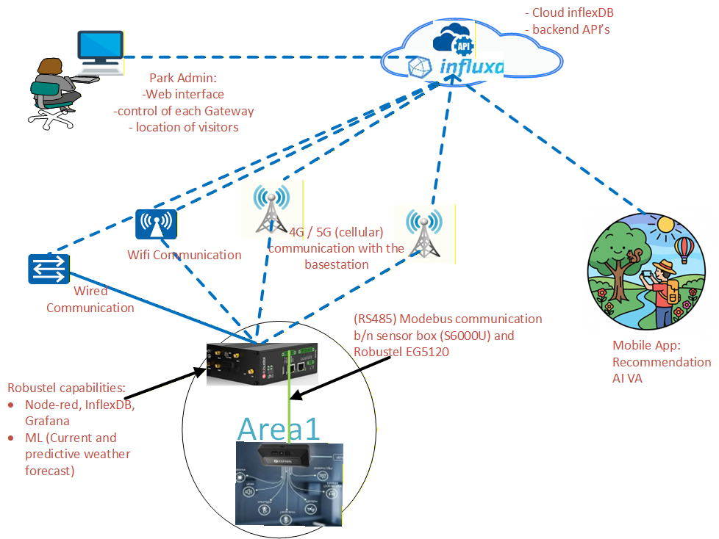
3. Macro-Functionalities:
These functionalities describe what the end-user (park visitor or administrator) experiences.
- Intelligent Trail Recommendation: Users receive trail suggestions based on environmental factors utilizing Content-Based Filtering.
- AI Virtual Assistant: A conversational Chatbot that provides information about park history, activities, and services.
- Real-Time Environmental Dashboard: A visual interface displaying current park metrics (Temperature, Humidity, Pressure, Noise levels).
- Weather Forecast Integration: The system alerts users to incoming weather changes (e.g., rain predicted in 2 hours) by cross-referencing sensor data with external meteorological APIs.( this feature will override the recommendation output if the predicted weather will be bad)
- User Localization & Mapping: The web interface tracks the user's position via GPS to show their location relative to park trails and sensor readings.
4. Micro-Functionalities
These functionalities describe the internal technical processes required to achieve the user goals.
A. Data Acquisition & Routing
- Sensor Input: The S6000U sensor collects raw data (Temp, Pressure, Light, Noise, etc.).
- External API Input (Weather): The system queries external weather APIs to fetch forecast data for the specific park coordinates.
- Node-Red Orchestration: Acts as the central nervous system. It triggers data collection, cleans the inputs, and routes data to the Database and ML models.
B. Machine Learning & Classification
- Trail Categorization: A Random Forest (or XGBoost) model trains on sensor data (Temperature, Pressure, Humidity, Light) to classify trail conditions (Tags).
- Hybrid Logic: Hard-coded thresholds are applied to specific parameters like Noise and Slope to refine the ML output.
- RAG Chatbot: The chatbot utilizes Retrieval-Augmented Generation (RAG). Park data is scraped, indexed, and fed into an LLM to answer user queries accurately.
C. Data Storage & Connectivity
- Geospatial & Time-Series Storage: The database stores environmental readings alongside user GPS logs to create historical heatmaps of park usage.
- Web-DB Connectivity: The website maintains a continuous connection with the database to fetch real-time recommendations and chat responses.
- Work Breakdown Structure (Team Roles)
To accommodate the expanded scope (Weather & GPS), responsibilities have been distributed as follows:
Student | Role | Technical Responsibilities
Sisay Desalegn | Sensor & External Data APIs | Setup and Configuration of S6000U/EG120.  Implementing the "Virtual Sensor" logic to fetch External Weather API data for the system.
Yonas Yifter | Node-Red Orchestration | Managing data flows between Sensors, Weather APIs, DB, and ML models. The "Spine" implementation.
Zakariye Hassan | Database Architecture | Schema design for sensor data.  Designing the storage structure for User GPS coordinates and historical weather logs.
Meron Temesgen | Data Visualization | Grafana dashboard creation.  Visualizing the "Local Sensor Data", "Forecasted Weather Data" And "main parameters of visitors"
Jhena Subol | Web Development & GPS | Frontend creation.  Implementing the HTML5 Geolocation API to capture and display User GPS location on the park map.
Husayn Ismail | ML (Recommendation) | Developing the Random Forest model for trail tagging and Content-Based Filtering algorithms.
Rima Kasem | ML (Chatbot) | Developing the RAG pipeline, Web Scraping for park info, and LLM integration.

